**What Are Stateful Applications**

Stateful applications are applications that store data and keep tracking it. All databases, such as MySQL, Oracle, and PostgreSQL, are examples of stateful applications. Stateless applications, on the other hand, do not keep the data. Node.js and Nginx are examples of stateless applications. For each request, the stateless application will receive new data and process it.

In a modern web application, the stateless application connects with stateful applications to serve the user’s request. A Node.js application is a stateless application that receives new data on each request from the user. This application is then connected with a stateful application, such as a MySQL database, to process the data. MySQL stores data and keeps updating the data based on the user’s request.

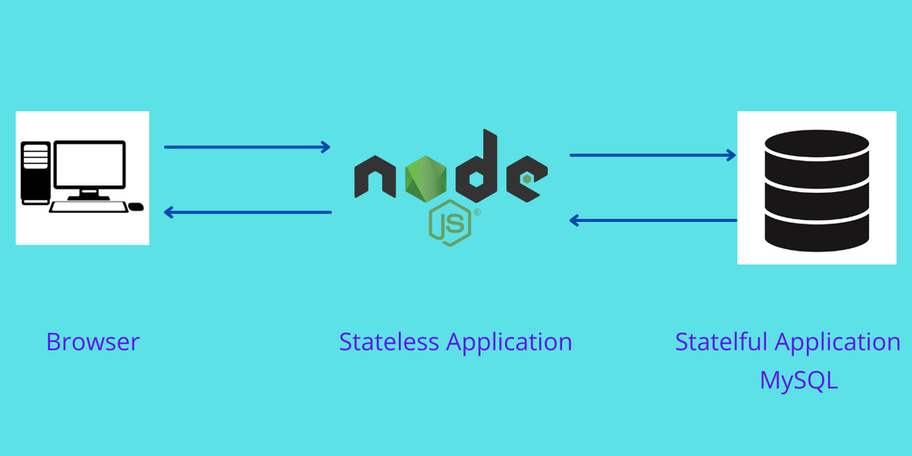

Read on to learn more about StatefulSets in the Kubernetes cluster — what they are, when to use them, how to create them, and what the best practices are.

**What Are StatefulSets?**

A StatefulSet is the Kubernetes controller used to run the stateful application as containers (Pods) in the Kubernetes cluster. StatefulSets assign a sticky identity — an ordinal number starting from zero — to each Pod instead of assigning random IDs for each replica Pod. A new Pod is created by cloning the previous Pod’s data. If the previous Pod is in the pending state, then the new Pod will not be created. If you delete a Pod, it will delete the Pod in reverse order, not in random order. For example, if you had four replicas and you scaled down to three, it will delete the Pod numbered 3.

The diagram below shows how the Pod is numbered from zero and how [Kubernetes persistent volume](https://loft.sh/blog/kubernetes-persistent-volumes-examples-and-best-practices/?utm_medium=reader&utm_source=loft-blog&utm_campaign=blog_kubernetes-statefulset-examples-and-best-practices) is attached to the Pod in the StatefulSets.

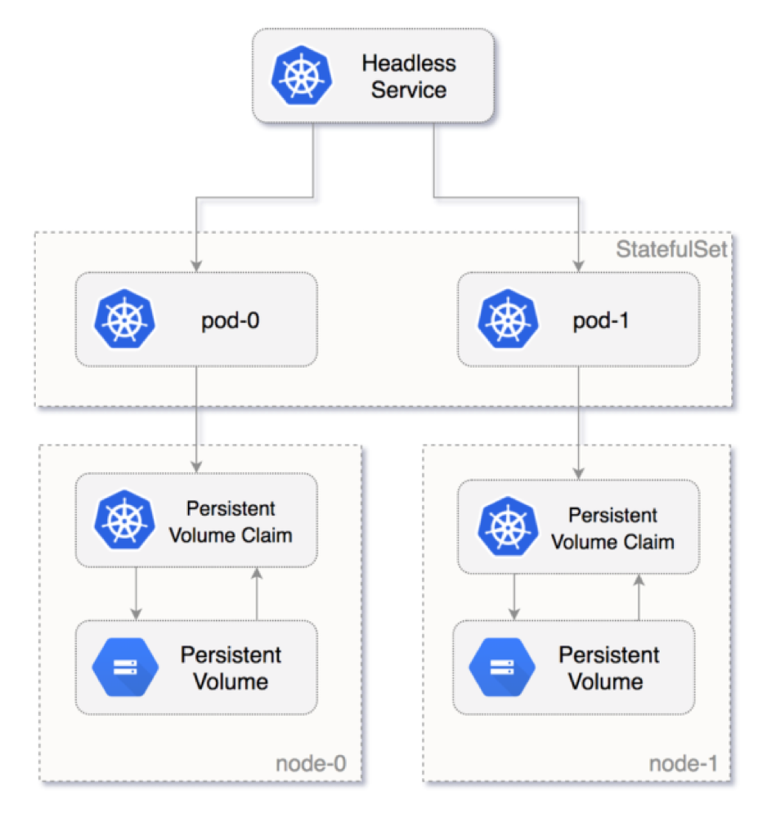

[**#**](https://loft.sh/blog/kubernetes-statefulset-examples-and-best-practices/#when-to-use-statefulsets?utm_medium=reader&utm_source=loft-blog&utm_campaign=blog_kubernetes-statefulset-examples-and-best-practices)**When to Use StatefulSets**

There are several reasons to consider using StatefulSets. Here are two examples:

1. Assume you deployed a MySQL database in the Kubernetes cluster and scaled this to three replicas, and a frontend application wants to access the MySQL cluster to read and write data. The read request will be forwarded to three Pods. However, the write request will only be forwarded to the first (primary) Pod, and the data will be synced with the other Pods. You can achieve this by using StatefulSets.
2. Deleting or scaling down a StatefulSet will not delete the volumes associated with the stateful application. This gives you your data safety. If you delete the MySQL Pod or if the MySQL Pod restarts, you can have access to the data in the same volume.

[**#**](https://loft.sh/blog/kubernetes-statefulset-examples-and-best-practices/#deployment-vs-statefulsets?utm_medium=reader&utm_source=loft-blog&utm_campaign=blog_kubernetes-statefulset-examples-and-best-practices)**Deployment vs. StatefulSets**

You can also create Pods (containers) using the Deployment object in the Kubernetes cluster. This allows you to easily replicate Pods and attach a storage volume to the Pods. The same thing can be done by using StatefulSets. What then is the advantage of using StatefulSets?

Well, the Pods created using the Deployment object are assigned random IDs. For example, you are creating a Pod named “my-app”, and you are scaling it to three replicas. The names of the Pods are created like this:

Copy

my-app-123ab  
my-app-098bd  
my-app-890yt

After the name “my-app”, random IDs are added. If the Pod restarts or you scale it down, then again, the Kubernetes Deployment object will assign different random IDs for each Pod. After restarting, the names of all Pods appear like this:

Copy

my-app-jk879  
my-app-kl097  
my-app-76hf7

All these Pods are associated with one load balancer service. So in a stateless application, changes in the Pod name are easily identified, and the service object easily handles the random IDs of Pods and distributes the load. This type of deployment is very suitable for stateless applications.

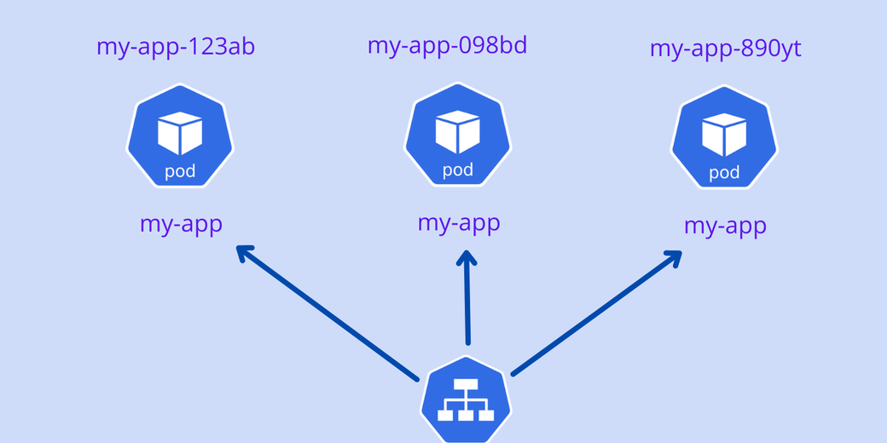

However, stateful applications cannot be deployed like this. The stateful application needs a sticky identity for each Pod because replica Pods are not identical Pods.

Take a look at the MySQL database deployment. Assume you are creating Pods for the MySQL database using the Kubernetes Deployment object and scaling the Pods. If you are writing data on one MySQL Pod, do not replicate the same data on another MySQL Pod if the Pod is restarted. This is the first problem with the Kubernetes Deployment object for the stateful application.

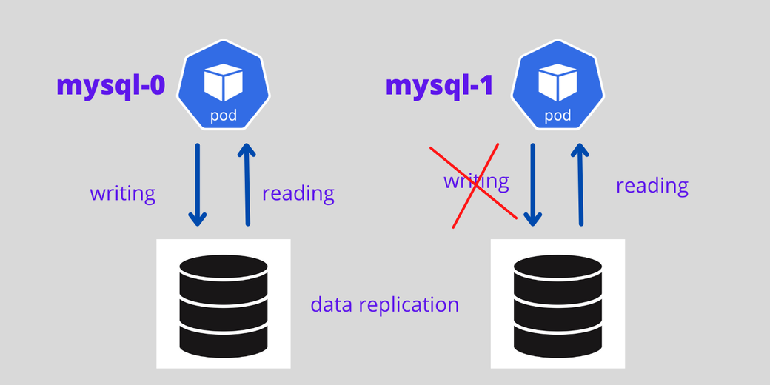

Stateful applications always need a sticky identity. While the Kubernetes Deployment object offers random IDs for each Pod, the Kubernetes StatefulSets controller offers an ordinal number for each Pod starting from zero, such as mysql-0, mysql-1, mysql-2, and so forth.

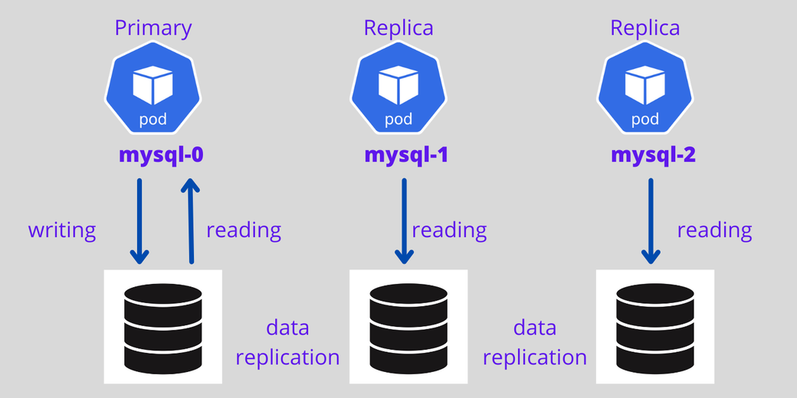

For stateful applications with a StatefulSet controller, it is possible to set the first Pod as primary and other Pods as replicas — the first Pod will handle both read and write requests from the user, and other Pods always sync with the first Pod for data replication. If the Pod dies, a new Pod is created with the same name.

The diagram below shows a MySQL primary and replica architecture with persistent volume and data replication architecture.

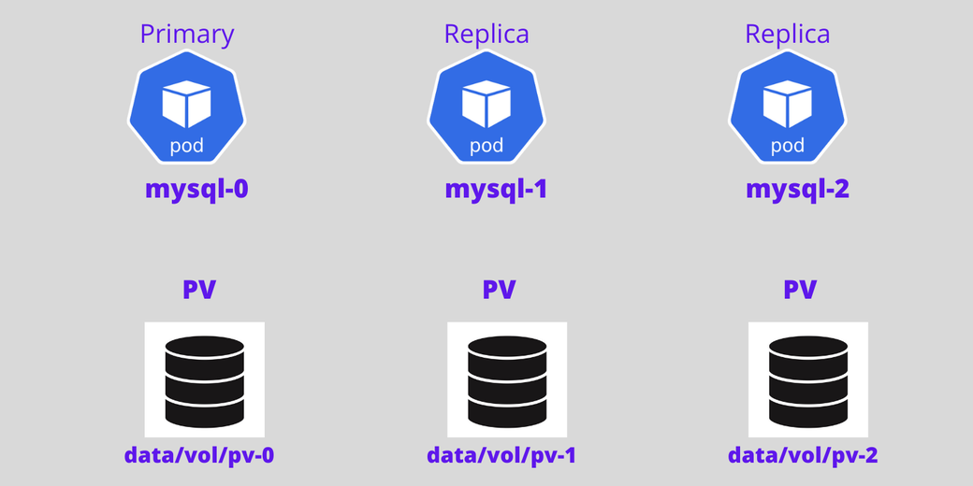

Now, add another Pod to that. The fourth Pod will only be created if the third Pod is up and running, and it will clone the data from the previous Pod.

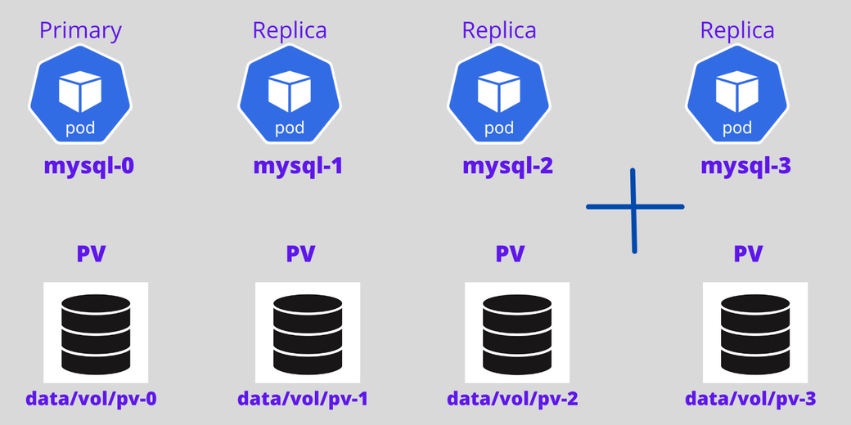

In summary, StatefulSets provide the following advantages when compared to Deployment objects:

1. Ordered numbers for each Pod
2. The first Pod can be a primary, which makes it a good choice when creating a replicated database setup, which handles both reading and writing
3. Other Pods act as replicas
4. New Pods will only be created if the previous Pod is in running state and will clone the previous Pod’s data
5. Deletion of Pods occurs in reverse order

[**#**](https://loft.sh/blog/kubernetes-statefulset-examples-and-best-practices/#how-to-create-a-statefulset-in-kubernetes?utm_medium=reader&utm_source=loft-blog&utm_campaign=blog_kubernetes-statefulset-examples-and-best-practices)**How to Create a StatefulSet in Kubernetes**

In this section, you will learn how to create a Pod for MySQL database using the StatefulSets controller.

[**#**](https://loft.sh/blog/kubernetes-statefulset-examples-and-best-practices/#create-a-secret?utm_medium=reader&utm_source=loft-blog&utm_campaign=blog_kubernetes-statefulset-examples-and-best-practices)**Create a Secret**

To start, you will need to create a Secret for the MySQL application that will store sensitive information, such as usernames and passwords. Here, I am creating a simple Secret. However, in a production environment, using the HashiCorp Vault is recommended. Use the following code to create a Secret for MySQL:

Copy

apiVersion: v1  
kind: Secret  
metadata:  
 name: mysql-password  
type: opaque  
stringData:  
 MYSQL_ROOT_PASSWORD: password

Save the code using the file name mysql-secret.yaml and execute the code using the following command on your Kubernetes cluster:

Copy

kubectl apply -f mysql-secret.yaml

Get the list of Secrets:

Copy

kubectl get secrets

[**#**](https://loft.sh/blog/kubernetes-statefulset-examples-and-best-practices/#create-a-mysql-statefulset-application?utm_medium=reader&utm_source=loft-blog&utm_campaign=blog_kubernetes-statefulset-examples-and-best-practices)**C**

**reate a MySQL StatefulSet Application**Before creating a StatefulSet application, check your volumes by getting the persistent volume list:

Copy

kubectl get pv  
NAME CAPACITY ACCESS MODES RECLAIM STATUS  
pvc-e0567 10Gi RWO Retain Bound

Next, get the persistent volume claim list:

Copy

kubectl get pvc

NAME STATUS VOLUME CAPACITY ACCESS  
mysql-store-mysql-set-0 Bound pvc-e0567d43ffc6405b 10Gi RWO

Last, get the storage class list:

Copy

kubectl get storageclass

NAME PROVISIONER RECLAIMPOLICY  
linode-block-storage linodebs.csi.linode.com Delete  
linode-block-storage-retain (default) linodebs.csi.linode.com Retain

Then use the following code to create a MySQL StatefulSet application in the Kubernetes cluster:

Copy

apiVersion: apps/v1  
kind: StatefulSet  
metadata:  
 name: mysql-set  
spec:  
 selector:  
 matchLabels:  
 app: mysql  
 serviceName: "mysql"  
 replicas: 3  
 template:  
 metadata:  
 labels:  
 app: mysql  
 spec:  
 terminationGracePeriodSeconds: 10  
 containers:  
 - name: mysql  
 image: mysql:5.7  
 ports:  
 - containerPort: 3306  
 volumeMounts:  
 - name: mysql-store  
 mountPath: /var/lib/mysql  
 env:  
 - name: MYSQL_ROOT_PASSWORD  
 valueFrom:  
 secretKeyRef:  
 name: mysql-password  
 key: MYSQL_ROOT_PASSWORD  
 volumeClaimTemplates:  
 - metadata:  
 name: mysql-store  
 spec:  
 accessModes: ["ReadWriteOnce"]  
 storageClassName: "linode-block-storage-retain"  
 resources:  
 requests:  
 storage: 5Gi

Here are a few things to note:

1. The kind is a StatefulSet. kind tells Kubernetes to create a MySQL application with the stateful feature.
2. The password is taken from the Secret object using the secretKeyRef.
3. The Linode block storage was used in the volumeClaimTemplates. If you are not mentioning any storage class name here, then it will take the default storage class in your cluster.
4. The replication count here is 3 (using the replica parameter), so it will create three Pods named mysql-set-0, mysql-set-1, and mysql-set-2.

Next, save the code using the file name mysql.yaml and execute using the following command:

Copy

kubectl apply -f mysql.yaml

Now that the MySQL Pods are created, get the Pods list:

Copy

kubectl get pods

NAME READY STATUS RESTARTS AGE  
mysql-set-0 1/1 Running 0 142s  
mysql-set-1 1/1 Running 0 132s  
mysql-set-2 1/1 Running 0 120s

[**#**](https://loft.sh/blog/kubernetes-statefulset-examples-and-best-practices/#create-a-service-for-the-statefulset-application?utm_medium=reader&utm_source=loft-blog&utm_campaign=blog_kubernetes-statefulset-examples-and-best-practices)**Create a Service for the StatefulSet Application**

Now, create the service for the MySQL Pod. Do not use the load balancer service for a stateful application, but instead, create a headless service for the MySQL application using the following code:

Copy

apiVersion: v1  
kind: Service  
metadata:  
 name: mysql  
 labels:  
 app: mysql  
spec:  
 ports:  
 - port: 3306  
 clusterIP: None  
 selector:  
 app: mysql

Save the code using the file name mysql-service.yaml and execute using the following command:

Copy

kubectl apply -f mysql-service.yaml

Get the list of running services:

Copy

kubectl get svc

[**#**](https://loft.sh/blog/kubernetes-statefulset-examples-and-best-practices/#create-a-client-for-mysql?utm_medium=reader&utm_source=loft-blog&utm_campaign=blog_kubernetes-statefulset-examples-and-best-practices)**Create a Client for MySQL**

If you want to access MySQL, then you will need a MySQL client tool. Deploy a MySQL client using the following manifest code:

Copy

apiVersion: v1  
kind: Pod  
metadata:  
 name: mysql-client  
spec:  
 containers:  
 - name: mysql-container  
 image: alpine  
 command: ['sh','-c', "sleep 1800m"]  
 imagePullPolicy: IfNotPresent

Save the code using the file name mysql-client.yaml and execute using the following command:

Copy

kubectl apply -f mysql-client.yaml

Then enter this into the MySQL client:

Copy

kubectl exec --stdin --tty mysql-client -- sh

Finally, install the MySQL client tool:

Copy

apk add mysql-client

[**#**](https://loft.sh/blog/kubernetes-statefulset-examples-and-best-practices/#access-the-mysql-application-using-the-mysql-client?utm_medium=reader&utm_source=loft-blog&utm_campaign=blog_kubernetes-statefulset-examples-and-best-practices)**Access the MySQL Application Using the MySQL Client**

Next, access the MySQL application using the MySQL client and create databases on the Pods.

If you are not already in the MySQL client Pod, enter it now:

Copy

kubectl exec -it mysql-client /bin/sh

To access MySQL, you can use the same standard MySQL command to connect with the MySQL server:

Copy

mysql -u root -p -h host-server-name

For access, you will need a MySQL server name. The syntax of the MySQL server in the Kubernetes cluster is given below:

Copy

stateful_name-ordinal_number.mysql.default.svc.cluster.local

#Example  
mysql-set-0.mysql.default.svc.cluster.local

Connect with the MySQL primary Pod using the following command. When asked for a password, enter the one you made in the “Create a Secret” section above.

Copy

mysql -u root -p -h mysql-set-0.mysql.default.svc.cluster.local

Next, create a database on the MySQL primary, then exit:

Copy

create database erp;  
exit;

Now connect the other Pods and create the database like above:

Copy

mysql -u root -p -h mysql-set-1.mysql.default.svc.cluster.local

mysql -u root -p -h mysql-set-2.mysql.default.svc.cluster.local

Remember that while Kubernetes helps you set up a stateful application, you will need to set up the data cloning and data sync by yourself. This cannot be done by the StatefulSets.

[**#**](https://loft.sh/blog/kubernetes-statefulset-examples-and-best-practices/#best-practices?utm_medium=reader&utm_source=loft-blog&utm_campaign=blog_kubernetes-statefulset-examples-and-best-practices)**Best Practices**

If you are planning to deploy stateful applications, such as Oracle, MySQL, Elasticsearch, and MongoDB, then using StatefulSets is a great option. The following points need to be considered while creating stateful applications:

1. Create a separate namespace for databases.
2. Place all the needed components for stateful applications, such as ConfigMaps, Secrets, and Services, in the particular namespace.
3. Put your custom scripts in the ConfigMaps.
4. Use headless service instead of load balancer service while creating Service objects.
5. Use the HashiCorp Vault for storing your Secrets.
6. Use the persistent volume storage for storing the data. Then your data won’t be deleted even if the Pod dies or crashes.

Deployment objects are the most used controller to create Pods in Kubernetes. You can easily scale these Pods by mentioning replication count in the manifest file. For stateless applications, using Deployment objects is most suitable. For example, assume you are planning to deploy your Node.js application and you want to scale the Node.js application to five replicas. In this case, the Deployment object is well suited.

The diagram below shows how Deployment and StatefulSets assign names to the Pods.

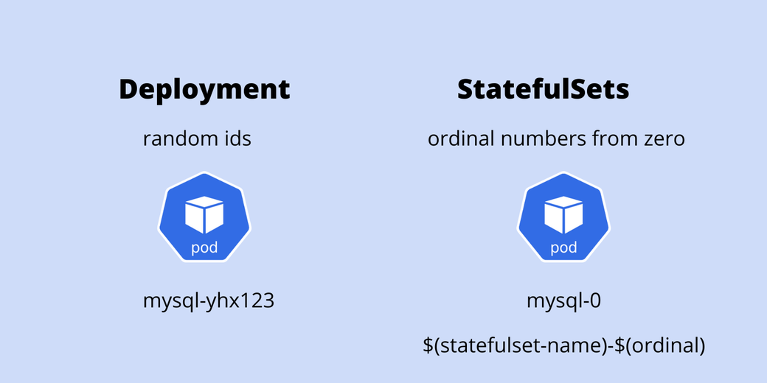

Stateful Sets create ordinal service endpoints for each Pod created using the replica option. The diagram below shows how the stateful Pod endpoints are created with ordinal numbering and how they communicate with each other.

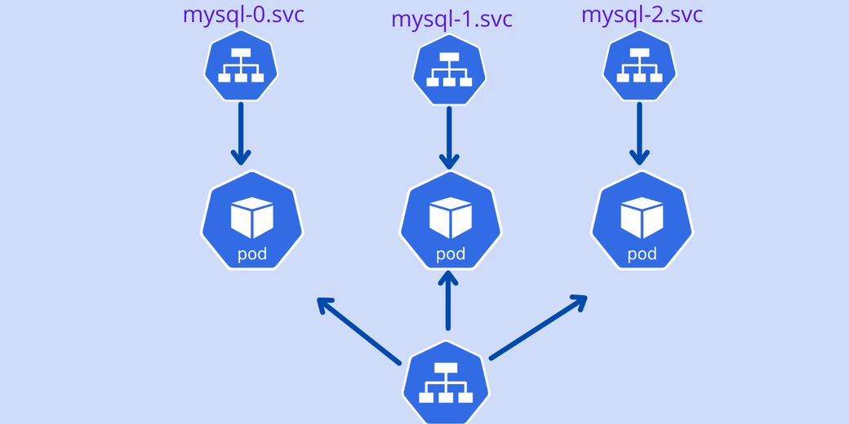

[**#**](https://loft.sh/blog/kubernetes-statefulset-examples-and-best-practices/#conclusion?utm_medium=reader&utm_source=loft-blog&utm_campaign=blog_kubernetes-statefulset-examples-and-best-practices)**Conclusion**

In this article, you learned about Kubernetes’s two main controllers for creating Pods: Deployments and StatefulSets. A Deployment object is well suited for stateless applications, and the StatefulSets controller is well suited for stateful applications. If you are planning to deploy stateful applications, such as MySQL and Oracle, then you should use the StatefulSets controller instead of the Deployment object.